# **Name: Abdurrahman Qureshi**

# **Roll No: 210451**

Practical No: 6

**1) WAP in JAVA Which will calculate GCD and LCM**

**CODE:**

import java.util.Scanner;

public class Main {

public static void main(String[] args) {

Scanner input = new Scanner(System.in);

System.out.print("Enter the First Number: ");

int num1 = input.nextInt();

System.out.print("Enter the Second Number: ");

int num2 = input.nextInt();

int gcd = 0;

for (int i = 1; i <= num1 && i <= num2; i++) {

if (num1 % i == 0 && num2 % i == 0) {

gcd = i;

}

}

int lcm = (num1 * num2) / gcd;

System.out.println("GCD of " + num1 + " and " + num2 + " is " + gcd);

System.out.println("LCM of " + num1 + " and " + num2 + " is " + lcm);

}

}

**OUTPUT:**

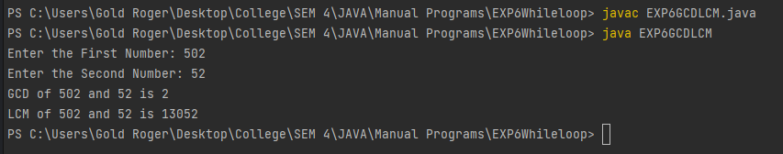

**2) WAP in JAVA which will print sum and reverse of ‘n’ digits number.**

**CODE:**

import java.util.Scanner;

public class JPRHWsumNRev

{

public static void main(String[] args)

{

Scanner userEnteredInt = new Scanner(System.in);

System.out.print("Enter Number: ");

int num, rem;

int rev = 0, sum = 0;

num = userEnteredInt.nextInt();

while (num > 0){

rem = num % 10;

rev = rev * 10 + rem;

sum = sum + rem;

num = num / 10;

}

System.out.println("Reverse of given number: "

+ rev);

System.out.println("Sum of digits of given number: "

+ sum);

}

}

**OUTPUT:**

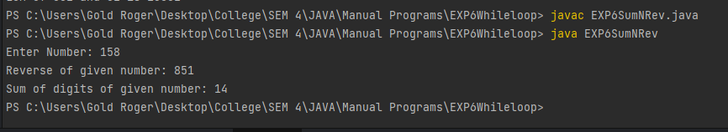

**3) WAP in JAVA Which will print Armstrong numbers between 1 to 500**

**CODE:**

class Main

{

public static void main(String[] arg)

{

int i=100,arm;

System.out.println("Armstrong numbers between 100 to 999");

while(i<1000)

{

arm=armstrongOrNot(i);

if(arm==i)

System.out.println(i);

i++;

}

}

static int armstrongOrNot(int num)

{

int x,a=0;

while(num!=0)

{

x=num%10;

a=a+(x*x*x);

num/=10 ;

}

return a;

}

}

**OUTPUT:**

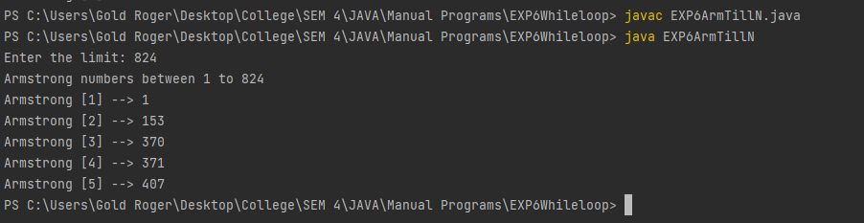

**4) WAP in JAVA to display numbers from 1 to 50**

**CODE:**

public class EXP61To50 {

public static void main(String args[])

{

System.out.println("Displaying 1 to 50...");

int i=1;

while (i<=50){

System.out.print(i + "\t");

if(i%10 == 0 ){

System.out.println();

}

i++;

}

}

}

**OUTPUT:**

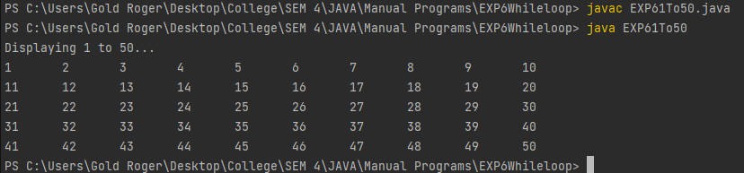

**5) WAP in java to check if the integer entered is an Armstrong number or not**

**CODE:**

import java.util.*;

public class EXP6ArmOrNot{

public static void main(String args[]){

Scanner sc = new Scanner(System.in);

System.out.print("Enter an integer to check if it is an armstrong number:");

int num = sc.nextInt();

int sum = 0 , r;

int temp = num;

while(temp>0){

r = temp % 10;

sum = sum + (r*r*r);

temp = temp / 10;

}

if(sum == num){

System.out.println("The entered number : " + num + " is an armstrong number");

}

else{

System.out.println("The entered number : " + num + " is not an armstrong number");

}}}

**OUTPUT:**

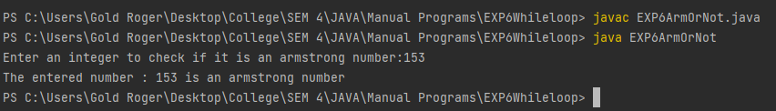

**6) WAP in java to check if the integer entered is a palindrome number or not**

**CODE:**

import java.util.Scanner;

public class EXP6PalindromeNum{

public static void main(String args[]){

Scanner sc = new Scanner(System.in);

int r,sum=0,temp;

System.out.print("Enter an integer to check if its a palindrome number:");

int n=sc.nextInt();

temp=n;

while(n>0) {

r=n%10;

sum=(sum*10)+r;

n=n/10;

}

if(temp==sum) {

System.out.println("The Entered number " + temp + " is a Palindrome Number ");

}

else{

System.out.println("The Entered number " + temp + " is not a palindrome Number");

}}}

**OUTPUT:**

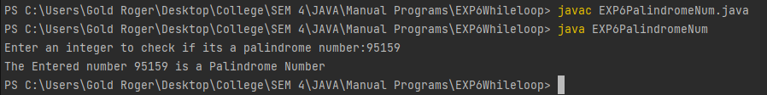

**7) WAP in java to count the number of +ve, -ve and 0’ s from user till n**

**CODE:**

import java.util.*;

public class EXP6CountNum {

public static void main(String args[]) {

Scanner sc = new Scanner(System.in);

System.out.print("Enter number of integers you will enter:");

int nOfNum = sc.nextInt();

int[] userEntered = new int[50];

int numOfZ = 0, numOfPI = 0, numOfNI = 0;

System.out.println();

for (int i = 0; i < nOfNum; i++) {

System.out.print("Enter " + (i + 1) + " Position number here -->");

userEntered[i] = sc.nextInt();

System.out.println();

}

for (int j = 0; j < nOfNum; j++) {

if (userEntered[j] == 0) {

numOfZ++;

} else if (userEntered[j] > 0) {

numOfPI++;

} else if (userEntered[j] < 0) {

numOfNI++;

}

}

System.out.println("Total number of positive integers entered = " + numOfPI);

System.out.println("Total number of negative integers entered = " + numOfNI);

System.out.println("Total number of zeroes entered = " + numOfZ);

}}

**OUTPUT:**

